The Chris Nifong Project

Original Jazz-Fusion and More

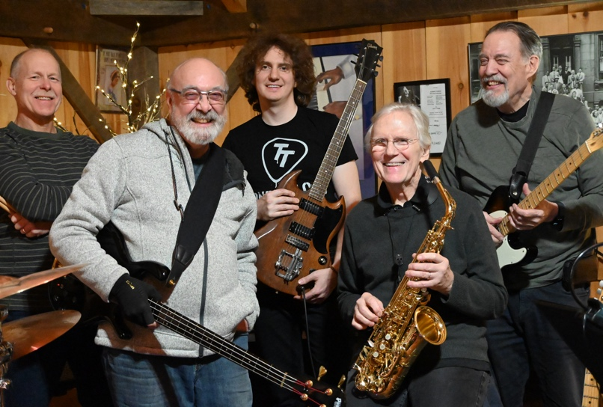

The Chris Nifong Project is a five-piece group playing original jazz-fusion compositions by its leader, Chris Nifong, along with other selectively curated jazz, rock, pop and blues tunes. Based in Massachusetts, The Project started out as a family band made up of all Berklee educated musicians and has evolved into a group of players both from Berklee and the community. Driven by a reverence for virtuoso technique and a love of melody, the repertoire is creative, accessible, layered and energizing. Chris often uses personal experiences like a trip to Cadillac Mountain in Maine, or a Vermont summer day as an inspiration for his writing. Just as often, the music comes from his deep listening to his heroes – Mike Stern, Allan Holdsworth, John Scofield, Bill Frisell, The Beatles, The Grateful Dead, Led Zeppelin and many others. The band delivers great music, burning solos and a ton of energy in live performances, and is equally capable when playing quieter, more acoustically oriented events.

Chris Nifong- Guitar

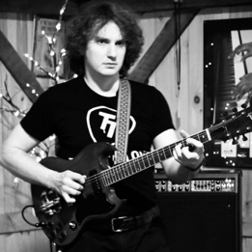

Starting at a very young age, Chris has been fascinated with all aspects of music. He began playing guitar at 13, attended the five-week sessions at Berklee College of Music beginning when he was 14, and graduated from Berklee with a Bachelor’s degree in Performance (Guitar). He went on to get his Master of Music Education (Autism Concentration) degree from Boston Conservatory at Berklee College of Music. He teaches music at The Tremont School in Concord, Massachusetts, as well as in the Berklee Institute for Accessible Arts Education program. He teaches private lessons at three different studios, including his own in Holden, Massachusetts called Mystic Farm Studios. Chris also taught at Plugged In Band Program in Needham for ten years, working with both ensembles and private students. As a multi-instrumentalist, Chris was selected to play pedal steel in the “Larry Klein Meets Berklee” concert, alongside Madeleine Peyroux and Luciana Sousa at the Berklee Performance Center. An experienced performer and composer, Chris has played in many local bands and has been leading The Chris Nifong Project for several years, primarily featuring his own compositions. His love of melody, texture, and complexity make his evocative music immediately compelling and groove-laced.

Bruce Nifong- Saxophone
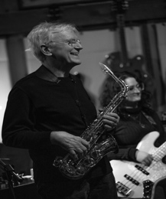
Photo: Greg Weintraub

A retired professor and Assistant Chair (Ensemble Department) at the Berklee College of Music (and Chris’s father), Bruce’s main instrument is alto saxophone, with a hefty dose of soprano thrown in. Bruce has played on many recordings and in international concert tours for CBS and Polydor Records, as well as touring throughout the States. He has most recently been the woodwind player on all of David Mash’s albums (https://davidmash.com) over the past five years, and also on all of Wisterio’s albums (Wisterio (@wisteriomusic) https://www.instagram.com/wisteriomusic, Wisterio open.spotify.com), along with many others throughout his career. His playing can seamlessly move between straight ahead jazz, pop, indie, rock, fusion, and big band. Known for his sweet sound and command of the improvisational arena, Bruce is comfortable in all genres of music.

Todd Rhodes- Drums

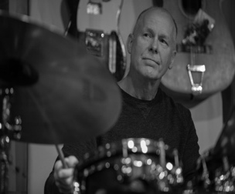

Photo: Greg Weintraub

Todd started snare drum lessons in the fourth grade. Not soon after, he was blown away while riding his bike past a house that was blasting the band Chicago out the window. He discovered progressive and atmospheric rock, followed by Heavy Weather and Bitches Brew in his high school years. At the urging of his father, he pursued a career in engineering rather than music. His musical hobbyist ambitions were shelved when his first child was born more than 25 years ago. All who know him would agree that he is now making up for lost time. He currently enjoys Afro-Cuban and Afro-Brazilian infused jazz.

Mark Snyder – Bass

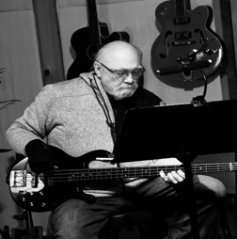
Mark has been a fixture on the Boston music scene since 1976. He has performed and/or recorded with The Gary Burton Quartet, Adam Nusbaum, Bob Moses, Tiger Okoshi, Stan Strickland, Brad Hatfield, The Coasters, The Drifters, Gary “U.S.” Bonds, Franky Ford, Tommy Row, Brian Hyland, Safam, and Ictus; as well as countless other jazz, r&b, and rock groups, all over the U.S. and much of Europe. Mark studied music at Ohio University and Berklee College of Music, where he graduated with a degree in Composition. Mark has composed, recorded, and performed jazz, rock, r&b, and classical music, for various instrumentation, including small groups, big band, concert band, chamber music, and film scores. He also plays trombone, and is leader of and composer for The Boneheads, a Trombone Choir that performs in the Boston area.
Peter Bell – Guitar
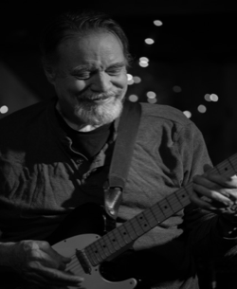

Photo: Greg Weintraub
Peter Bell, a veteran of the Electronic Production and Design faculty at Berklee College of Music, is a producer, composer, and guitarist. His compositions and productions include the themes to This Old House, New Yankee Workshop, Victory Garden, the ABC After School Special, the award-winning film Radio Cape Cod, as well as countless jingles and production tracks. Peter has produced tracks featuring many world-class musicians, including Bonnie Raitt, Tracy Bonham, Livingston Taylor, Kate Taylor, Alex Taylor, Lalah Hathaway, Jon Poussette-Dart, The New Kids On The Block, Rebecca Parris, Mick Goodrick, Mike Metheny, Mark Sandman of Morphine, Allen Estes, Patty Griffin, and others. He has recorded with Bonnie Raitt on Warner Brothers and the James Montgomery Band on Capricorn and Island Records, among many others. His awards include two Emmys, seven NEBA awards, and six ASCAP awards. Peter holds a Bachelor of Music in Jazz Composition and Arranging from Berklee College of Music and a BA in Government from Harvard University. He has also authored a book entitled Creating Commercial Music, and recently released a new album entitled Just Sayin.

BOOKING INFORMATION:
cnifong@alumni.berklee.edu
Cell: 978-460-3250
mchambers54@verizon.net
Cell:978-460-1150

